**PRACTICAL - 1**

**AIM:** Identify the requirement and set objectives for a software project.

**Scenario:** Assume you are the project manager for a software development project. The project involves creating a new mobile application for a client. The client wants the application to enhance user engagement and include specific features.

**Task:**

1. Identify the requirements and list the key objectives for the PS APP and Inventory Management system.
2. Ensure that each objective follows the SMART criteria.
3. Create Epic, Stories and Tasks using Jira software.

**Solution :**

**Project Title :** PS APP

**Key Objective :**

* Develop user authentication and profile management system.
* Implement an inventory management system for in-app purchases and DLC tracking.
* Create a content browsing feature for games and media.
* Enhance user engagement with achievements, rewards, and notifications.
* Ensure cross-device synchronization of user data and content.

**SMART Criteria :**

* **S**pecific : Create an engaging, user-friendly mobile app with seamless onboarding, login, registration, password recovery, and a personalized home screen.
* **M**easurable : The app will achieve 90% user engagement by allowing users to register and log in easily, reducing drop-off during onboarding by 30%, and ensure password recovery is completed by at least 95% of users who request it.
* **A**chievable : Develop the app with the required features using an agile methodology, testing each feature in iterative sprints.
* **R**elevant : These features align with the client’s goal of increasing user engagement and retention through simplified access and personalized experience.
* **T**ime-bound : The application should be completed within 8 weeks, with specific milestones at the end of each sprint (2 weeks per sprint).

**Key Requirements :**

**Epic 1 : User Onboarding and Authentication**

**Story 1 :** Landing/Onboarding Page

* **Task 1 :** Design the “Landing/Onboarding” page with an engaging introduction to the app.
* **Task 2 :** Add a “Get Started” button that leads to the login/registration page.

**Story 2 :** User Login

* **Task 1 :** Create a login page with email and password fields.
* **Task 2 :** Implement token-based authentication (JWT).
* **Task 3 :** Add an option for users to log in via social media accounts (Google/Facebook).

**Story 3 :** User Registration

* **Task 1 :** Design a Registration form with fields for username, email and password.
* **Task 2 :** Implement server-side validation for registration inputs.
* **Task 3 :** Store user registration data securely in the database.

**Story 4 :** Forgot Password

* **Task 1 :** Design a “Forgot Password” page with an email input for password reset.
* **Task 2 :** Implement email-based password recovery.

**Epic 2 : Home Page and Content Display**

**Story 1 :** Home Page Layout

* **Task 1 :** Design the homepage with a carousel for featured games.
* **Task 2 :** Create a section with game cards to display popular games.
* **Task 3 :** Implement a search bar for users to search specific games.

**Story 2 :** Game Interaction

* **Task 1 :** Implement tap functionality on game cards to view game details.
* **Task 2 :** Integrate a rating system to allow users to rate games.

**Epic 3 : Shopping Cart and Favourite System**

**Story 1 :** Shopping Cart

* **Task 1 :** Design the shopping cart page with options to view added items.
* **Task 2 :** Implement functionality to add, remove and edit items in the cart.
* **Task 3 :** Integrate the checkout process for in-app purchases.

**Story 2 :** Favourite System

* **Task 1 :** Add functionality to allow users to mark games as favourites.
* **Task 2 :** Display a list of favourite games on the “Favourite” page.

**Epic 4 : Notification and User Profile**

**Story 1 :** Notification System

* **Task 1 :** Implement a notification system to notify users of new content and updates.
* **Task 2 :** Design a notification page to show all user alerts.

**Story 2 :** User Profile

* **Task 1 :** Create a profile page to display personal details such as username, email and preferences.
* **Task 2 :** Add functionality to update personal details and preferences.
* **Task 3 :** Integrate a profile picture upload option.
* **Task 4 :** Also add a tab for the order history.

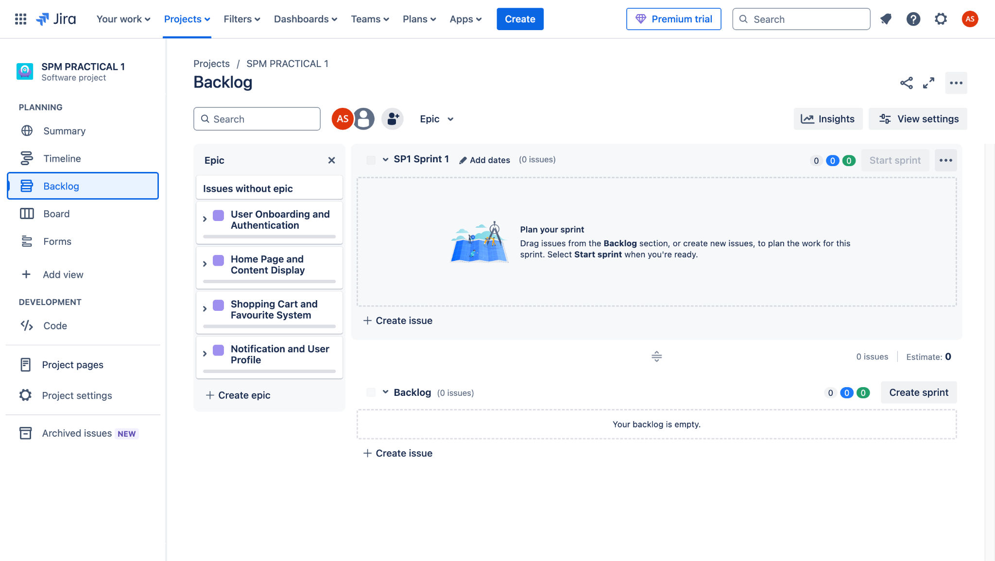

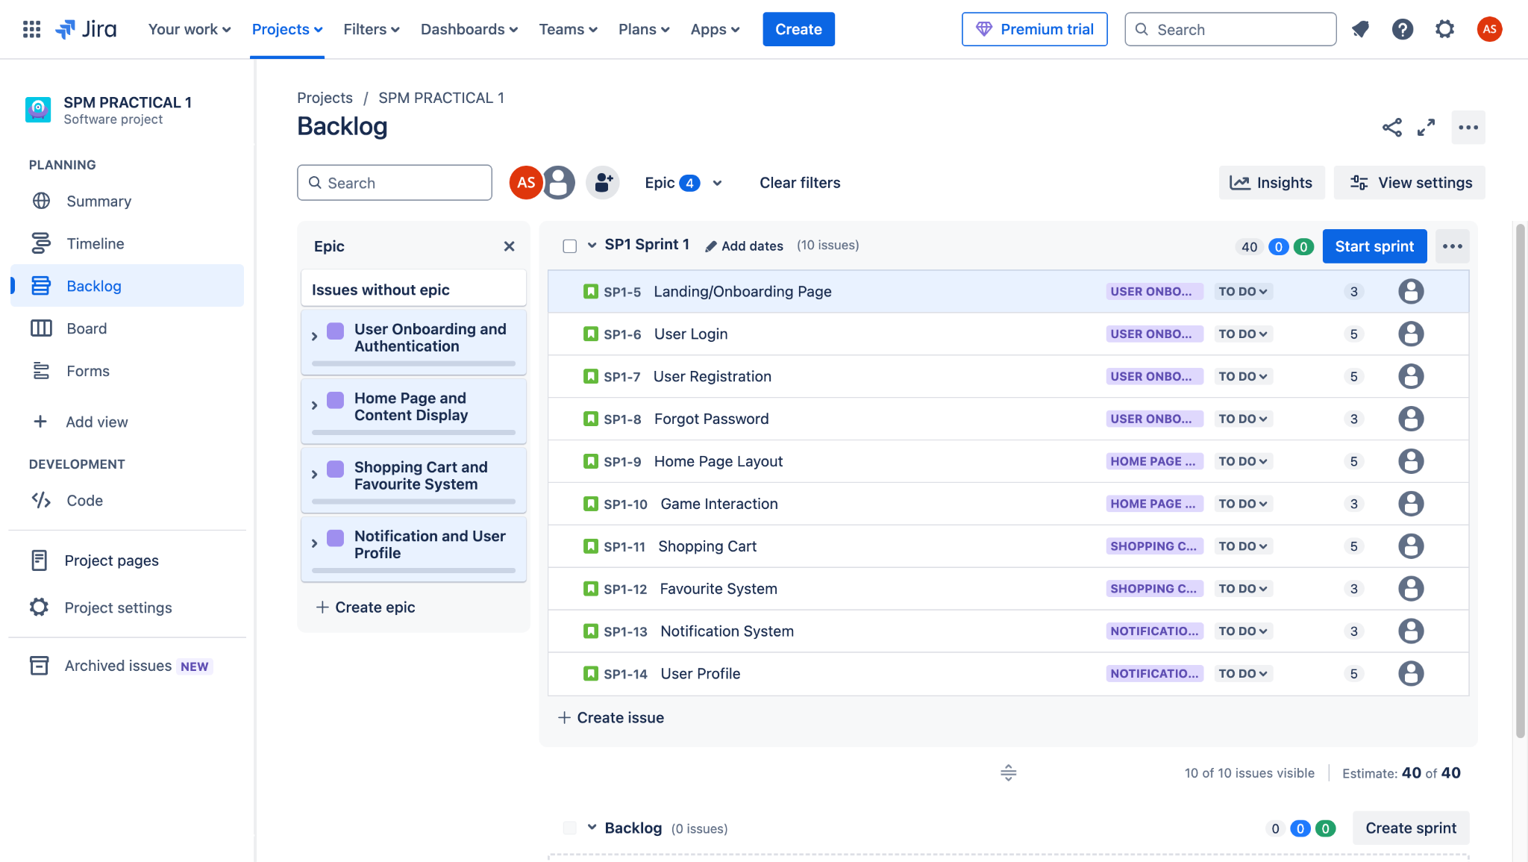

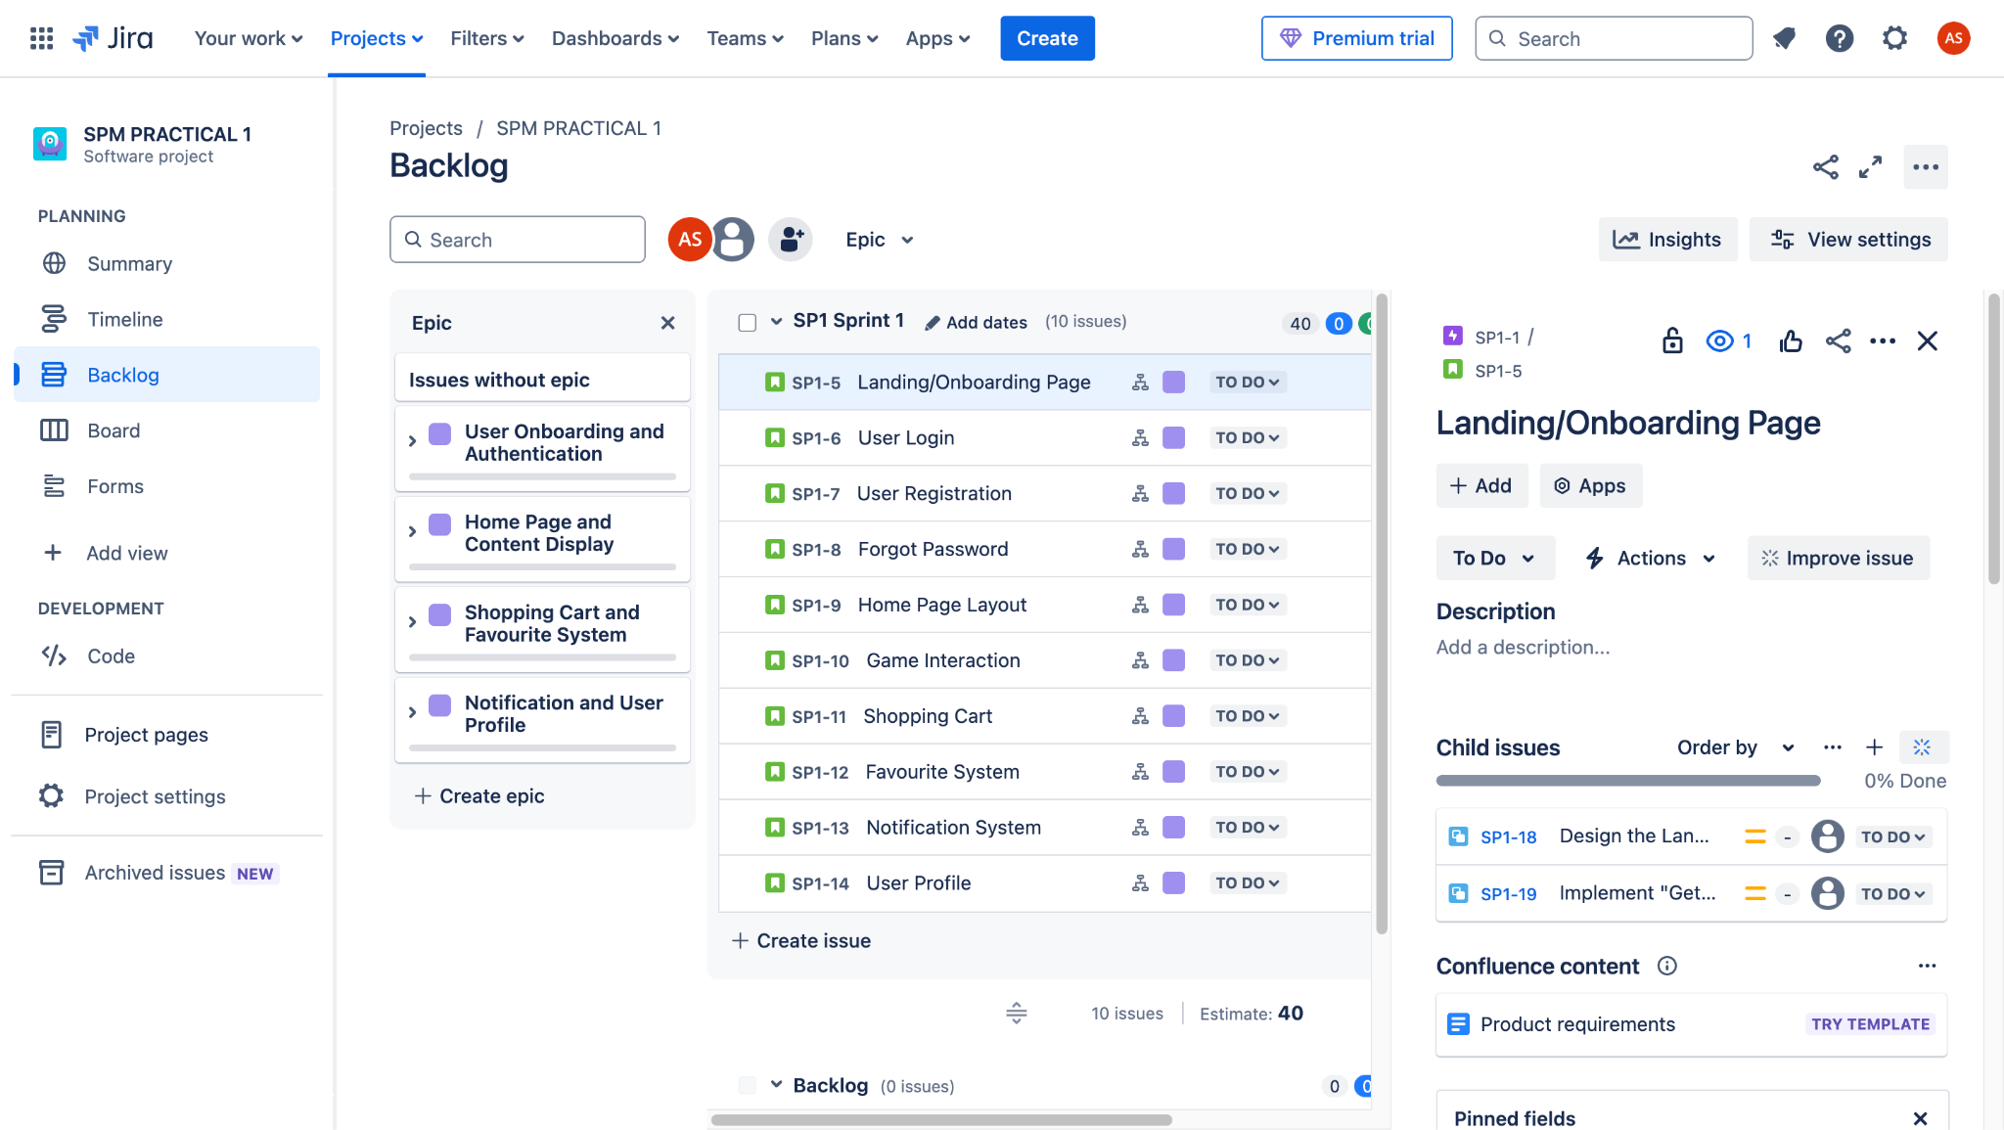

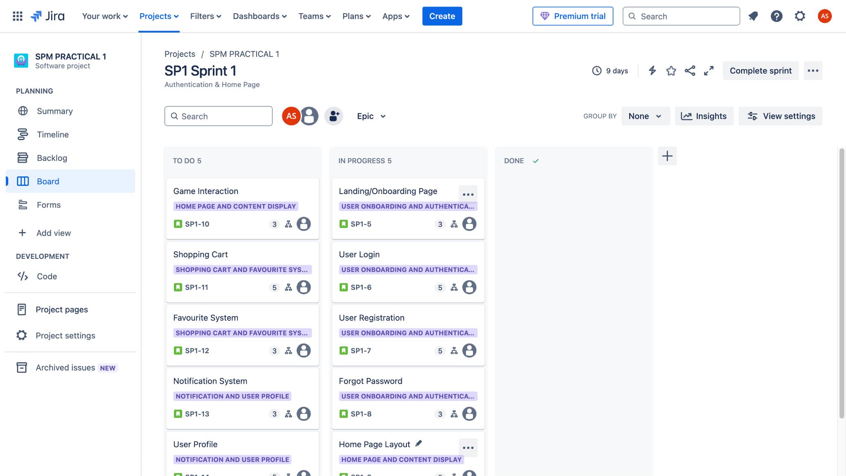

**Project Title :** Stock Inventory Management System

**Key Objective :**

* Develop a secure user authentication and role-based access system.
* Implement an efficient stock management system for tracking inventory levels and stock movements.
* Create a product catalog with categorization, search, and filtering options.
* Enable order management, including stock purchases, sales, and restocking.
* Implement a notification system for low stock alerts and order updates.

**SMART Criteria :**

* **S**pecific**:** Build an inventory management system with features for product tracking, stock monitoring, order processing, and real-time notifications.
* **M**easurable**:** Ensure 95% accuracy in stock tracking, reduce manual inventory errors by 40%, and improve order processing efficiency by 50%.
* **A**chievable**:** Develop the system in iterative sprints using agile methodology with regular testing.
* **R**elevant**:** The system addresses the need for streamlined inventory tracking and order management, improving business efficiency.
* **T**ime-bound**:** Complete the application within 8 weeks, with bi-weekly sprints focusing on key modules.

**Key Requirements :**

**Epic 1 : User Authentication and Role Management**

**Story 1 :** User Login & Role-Based Access

* **Task 1:** Implement a secure login system for admins, managers, and staff.
* **Task 2:** Restrict access based on user roles (e.g., only admins can add new products).

**Story 2 :**User Registration & Profile Management

* **Task 1:** Design a registration form for new users with role selection.
* **Task 2:** Implement profile management features for updating user details.

**Story 3 :** Password Recovery

* **Task 1 :** Implement a "Forgot Password" feature using email verification.\

**Epic 2 : Stock Management System**

**Story 1 :** Product Catalog

* **Task 1:** Develop a database schema for product details (name, SKU, price, quantity, supplier, etc.).
* **Task 2:** Create a product listing page with categorization and filtering options.

**Story 2 :** Stock Tracking & Updates

* **Task 1:** Implement real-time stock level tracking.
* **Task 2:** Add functionality to update stock when new items are received or sold.

**Epic 3 : Order Management**

**Story 1 :** Stock Purchase Orders

* **Task 1:** Create a module for adding new stock purchase entries.
* **Task 2:** Implement approval workflow for purchase orders.

**Story 2 :**  Sales Order Processing

* **Task 1:** Develop an interface to create and manage sales orders.
* **Task 2:** Integrate automatic stock deduction when an order is confirmed.

**Epic 4 : Notification & Reporting**

**Story 1 :** Low Stock Alerts

* **Task 1 :** Implement an automatic alert system for low stock levels.

**Story 2 :** Order & Inventory Reports

* **Task 1:** Generate daily, weekly, and monthly reports on stock levels and order history.

